 

**Communication Project**

**Project 1**

**3rd Year Comm. | Spring 2025**

|  |  |  |
| --- | --- | --- |
| **NAME** | **SECTION** | **ID** |
| **Youssef Khaled Omar Mahmoud** | **4** | **9220984** |
| **Omar Ayman Amin Mohamed** | **3** | **9220528** |
| **Ahmed Mohamed Ahmed Sultan** | **1** | **9220080** |
| **Shahd Hamad Shaban Saleh** | **2** | **9220401** |
| **Mohamed Ahmed Abd El Hakam** | **3** | **9220647** |

**Instructor: Eng. Mohamed Khaled**

**Dr. Mohammed Nafie & Dr. Mohamed Khairy**

# **Contents**

A. **Contents** 2

**B.** **Table of Figures** 3

**C.** **Role of Each Member** 4

**D.** **Project Description** 5

**E.** **Introduction** 5

**F.** **Control Variables** 5

**G.** **Generation of Data** 5

**H.** **polar NRZ ensemble creation** 5

**I.** **Uni polar NRZ ensemble creation** 6

**J.** **Generation of Polar realization** 6

**K.** **Random initial time shift** 6

**L.** **Questions** 7

**1.** **Statistical Mean** 7

**1.1.** **Hand Analysis** 7

**1.2.** **Code Snippet** 8

**2.** **Statistical Autocorrelation** 9

**2.1.** **Hand Analysis** 9

**2.2.** **Code Snippet** 10

**3.** **Is the Process Stationary** 11

**4.** **The time mean and autocorrelation function for one waveform** 11

**4.1.** **Average Time Mean** 11

**4.2.** **Average Time Auto Correction** 14

**5.** **Is The Random Process Ergodic** 15

**6.** **the PSD & Bandwidth of the Ensemble** 16

**M.** **Appendix** 17

# **Table of Figures**

Figure 1 Realization 6

Figure 2 Plot of Statistical Mean 7

Figure 3 Auto Correction plot 10

Figure 4Time Mean Ploar NRZ 11

Figure 5 Time Mean Ploar RZ 11

Figure 6 Average time mean plot for all line codes 12

Figure 7 Time Mean Uni polar NRZ 12

Figure 8 Time Auto Correlation 13

Figure 9 Comparison Between Time and Statistical Mean 14

Figure 10 PSD plot of the Ensemble 15

# **Role of Each Member**

|  |  |
| --- | --- |
| Role | Name |
| code the generated waves | Youssef Khaled |
| compute the realization calculation | Ahmed Mohamed |
| compute the time calculation | Shahd Hamed |
| report | Mohamed Ahmed, Omar Ahmed |

# **Project Description**

Using software radio technique (SDR) to transmit stream of randomness bits through an ideal channel (which performing a small delay) using Matlab. Performing measures and analysis to see the performance of the system through three main line codes (unipolar, polar nrz and polar rz).

# **Introduction**

Software radio is a revolutionary approach that brings the programming code directly to the antenna, minimizing reliance on traditional radio hardware.

By doing so, it transforms challenges associated with radio hardware into software- related issues. Unlike conventional radios, where signal processing primarily relies on analog circuitry or a combination of analog and digital chips, software radio operates by having software dictate both the transmitted and received waveforms.

This paradigm shift allows for greater flexibility and adaptability in radio systems, as they can be easily reconfigured and optimized through software updates, rather than hardware modifications.

# **Control Variables**

A = 4 → amplitude of line code

rows_num = 500 → number of realizations

real_length = 100 → length of realization (in bits)

samples_num = 7→ number of samples per bit

samples_per_real → total samples per realization (700 samples)

fs = 100 → sampling frequency

# **Generation of Data**

Using the function: “**Randi**” to generate random binary data of size 500x101

(500 waveforms each with 101 bits). This data represents the binary bits that need to be encoded.

Data = randi([0,1], rows_num, real_length+1);

# **polar NRZ ensemble creation**

* The data consists of 0s and 1s. We converted these values to A and -A respectively.
* Then, we utilized the “**repelem”** function to repeat each element seven times.

polar_NRZ_amplitude = (2 * Data - 1) * A;

polar_NRZ_reals = repelem (polar_NRZ_amplitude, 1, samples_num);

# **Uni polar NRZ ensemble creation**

* We then generate unipolar NRZ amplitudes along with its realization.
* We convert data (1,0) to 1 →A ,0→ 0 to have uni_polar_NRZ.

uni_polar_NRZ_amplitude = Data * A;

uni_polar_NRZ_reals = repelem (uni_polar_NRZ_amplitude, 1, samples_num);

# **Generation of Polar realization**

polar_RZ_reals = polar_NRZ_reals;

for i = 1:rows_num

for j = 5:7:705

polar_RZ_reals(i, j:j+2) = 0;

end

end

* we then generate polar RZ amplitudes along with its realization.
* We generate polar_NRZ By setting samples to zero during the middle of each bit period, the code effectively generates the Polar RZ signal from the Polar NRZ signal.
* The interval [j:j+2] represents the middle part of the bit period, and setting those samples to zero creates the RZ waveform.

# **Random initial time shift**

* Generating a single random initial time delay that can range from ‘0’ to ‘6’ samples for each waveform using the function “randi”.

start_indices = randi([0, 6], rows_num, 1);

* Then, we utilized the randi function to generate a random number ranging from 0 to 6, which represents the delay or start time, then we take the elements from this random index (start_indices) to 700+( start_indices)

for i = 1:rows_num

start_index = start_indices(i);

end_index = samples_per_real + start_index;

Rndm_shift_polar_NRZ(i, :) = polar_NRZ_reals(i, start_index+1:end_index);

Rndm_shift_uni_polar_NRZ(i, :) = uni_polar_NRZ_reals(i, start_index+1:end_index);

Rndm_shift_polar_RZ(i, :) = polar_RZ_reals(i, start_index+1:end_index);

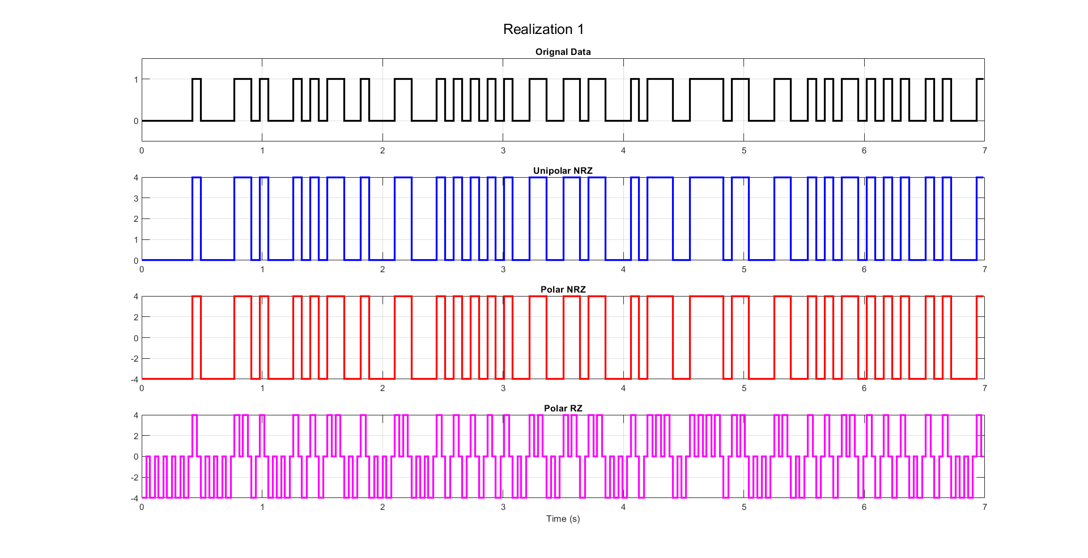end

Figure Realization

# **Questions**

## **Statistical Mean**

### **Hand Analysis**

For the “Statistical Mean” which represents the average of all the realizations at the same time instant, let us consider the first line code method “Unipolar NRZ”

𝜇𝑋(𝑡) = 0 ∗ 0.5 + 4 ∗ 0.5 = 2 (𝐶𝑜𝑛𝑠𝑡𝑎𝑛𝑡 𝑎𝑐𝑟𝑜𝑠𝑠 𝑡𝑖𝑚𝑒)

And in the same matter, we can calculate the “Statistical Mean” for both “Polar NRZ” and “Polar RZ” as following:

𝜇𝑋_𝑃𝑁𝑅𝑍(𝑡) = 4 ∗ 0.5 + (−4) ∗ 0.5 = 0 (𝐶𝑜𝑛𝑠𝑡𝑎𝑛𝑡 𝑎𝑐𝑟𝑜𝑠𝑠 𝑡𝑖𝑚𝑒)

𝜇𝑋_𝑃𝑅𝑍(𝑡) = 4 ∗ 0.5 + (−4) ∗ 0.5 = 0 (𝐶𝑜𝑛𝑠𝑡𝑎𝑛𝑡 𝑎𝑐𝑟𝑜𝑠𝑠 𝑡𝑖𝑚𝑒)

### **Code Snippet**

Col_Sum_pol_NRZ = zeros(1, samples_per_real); % initialization of sum matrix

Col_Sum_uni_pol_NRZ = zeros(1, samples_per_real); % initialization of sum matrix

Col_Sum_pol_RZ = zeros(1, samples_per_real); % initialization of sum matrix

for k = 1 : samples_per_real

for j = 1 : rows_num

Col_Sum_pol_NRZ(k) = Col_Sum_pol_NRZ(k) + Rndm_shift_polar_NRZ(j, k);

Col_Sum_uni_pol_NRZ(k) = Col_Sum_uni_pol_NRZ(k) + Rndm_shift_uni_polar_NRZ(j, k);

Col_Sum_pol_RZ(k) = Col_Sum_pol_RZ(k) + Rndm_shift_polar_RZ(j, k);

end

end

* 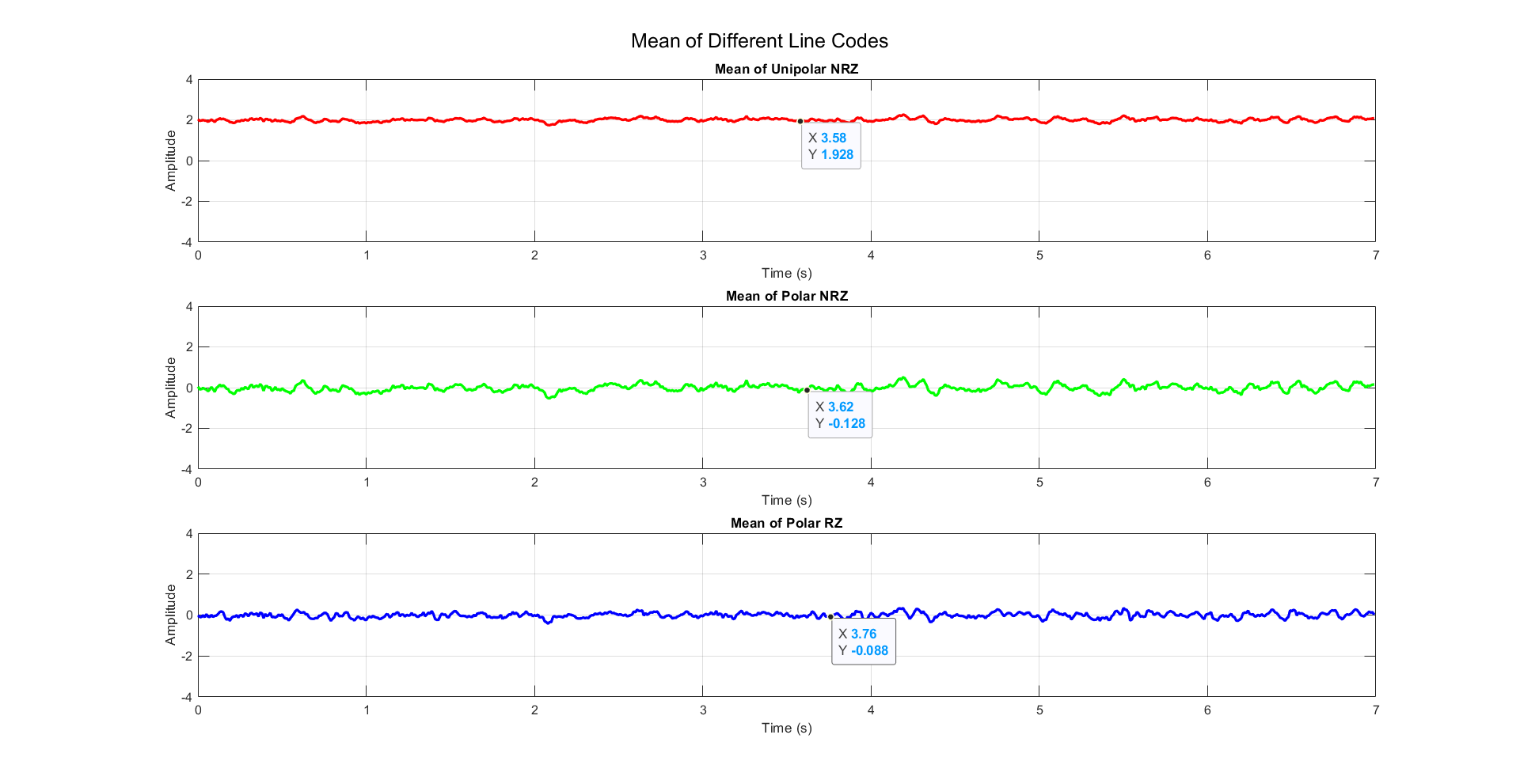we have two loops, the outer one for the time instants (K) and the inner for the number of realizations (j).

Figure Plot of Statistical Mean

* As expected, polar RZ & NRZ have almost zero mean and the uni polar has mean around 2 Bec its amplitude ranges from 0:4

## **Statistical Autocorrelation**

### **Hand Analysis**

𝑹𝑿(𝝉) = 𝑬[𝑿(𝝉) 𝑿(𝒕 + 𝝉)] = ∑ 𝑿(𝝉) 𝑿(𝒕 + 𝝉) 𝑷(𝑿(𝝉) 𝑿(𝒕 + 𝝉))

* + **For Unipolar NRZ:**

We have 2 cases **(Considering T to be 70ms or 7 samples),**

1. |𝝉| < 𝑻

𝑅𝑋(𝜏) = 𝐸[𝑋(𝜏) 𝑋(𝑡 + 𝜏)]

= 42 ∗ 𝑃(4,4) + 02 ∗ 𝑃(0,0) + 4 ∗ 0 ∗ 𝑃(0,4) + 0 ∗ 4 ∗ 𝑃(4,0)

= 42 ∗ 𝑃(4,4)

𝑃(4,4) = 𝑃(𝑋(𝑡 + 𝜏) = 4 | 𝑋(𝑡) = 4) ∗ 𝑃(𝑋(𝑡) = 4)

𝑃(𝑋(𝑡 + 𝜏) = 4 | 𝑋(𝑡) = 4) = 𝑃(𝑇̅) + 𝑃(𝑇) ∗ 𝑃(𝑋(𝑡 + 𝜏) = 4)

1. |𝝉| > 𝑻

𝑅𝑋(𝜏) = 𝐸[𝑋(𝜏) 𝑋(𝑡 + 𝜏)]

= 42 ∗ 0.5 ∗ 0.5 + 02 ∗ 0.5 ∗ 0.5 + 4 ∗ 0 ∗ 0.5 ∗ 0.5 + 0 ∗ 4 ∗ 0.5 ∗ 0.5

= 42 ∗ 0.5 ∗ 0.5

= 4

* + And using the same flow, we can find that the ACF for “**Polar NRZ**” is
  + And similarly, the ACF for “**Polar RZ**” is

**And as we know:**

𝑇𝑜𝑡𝑎𝑙 𝑃𝑜𝑤𝑒𝑟 = 𝑅𝑋(0) & 𝐷𝐶 𝑃𝑜𝑤𝑒𝑟 = 𝑅𝑋(∞)

𝐴𝐶 𝑃𝑜𝑤𝑒𝑟 = 𝑇𝑜𝑡𝑎𝑙 𝑃𝑜𝑤𝑒𝑟 − 𝐷𝐶 𝑃𝑜𝑤𝑒𝑟

|  |  |  |  |
| --- | --- | --- | --- |
|  | **Unipolar NRZ** | **Polar NRZ** | **Polar RZ** |
| **Total Power** | **8** | **16** | **8** |
| **DC Power** | **4** | **0** | **0** |
| **AC Power** | **4** | **16** | **8** |

### **Code Snippet**

averages_pol_NRZ = zeros(1, 700);

averages_uni_pol_NRZ = zeros(1, 700);

averages_pol_RZ = zeros(1, 700);

for i = 0:699

result_column_pol_NRZ = Rndm_shift_polar_NRZ(:, 1) .* Rndm_shift_polar_NRZ(:, i+1);

averages_pol_NRZ(i+1) = mean(result_column_pol_NRZ);

end

for i = 0:699

result_column_uni_pol_NRZ = Rndm_shift_uni_polar_NRZ(:, 1) .* Rndm_shift_uni_polar_NRZ(:, i+1);

averages_uni_pol_NRZ(i+1) = mean(result_column_uni_pol_NRZ);

end

for i = 0:699

result_column_pol_RZ = Rndm_shift_polar_RZ(:, 1) .* Rndm_shift_polar_RZ(:, i+1);

averages_pol_RZ(i+1) = mean(result_column_pol_RZ);

end

t = -699 : 699;

figure("name", "Statistical Autocorrelation");

**Annotations**

* The Statistical Autocorrelation is created by taking the element-wise product of each column with the first column of a selected matrix of data points, then averaging the resulting column-wise products.
* To guarantee that Autocorr is an even fun we concatenate between the result of fliplr fun & the averages vector before flipping (2:700 to ensure no repeated value at zero)
* The resulting autocorrelation values are plotted against the corresponding time delays (τ). We observe that at τ = 0 the autocorrelation with the point itself is maximum, indicating perfect correlation. However, the other points are around zero to be exactly zero it requires an infinite number of samples.

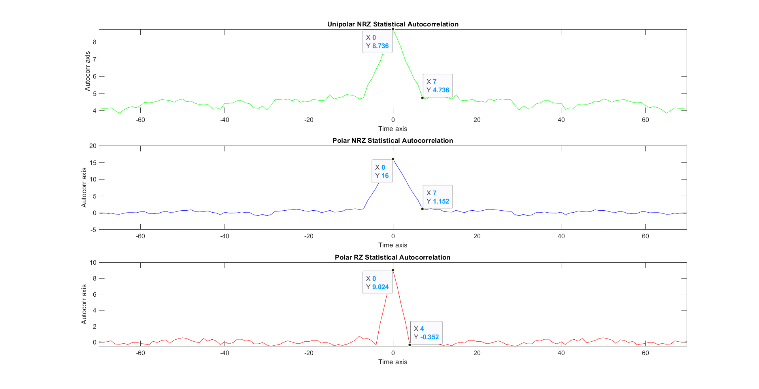

Figure Auto Correction plot

## **Is the Process Stationary**

* Yes, the process is stationary (WSSP) because the mean is constant function in time as shown in Figure 2 Plot of Statistical Mean and theoretically the autocorrelation depends only on the time difference not the absolute time.

## **The time mean and autocorrelation function for one waveform**

### **Average Time Mean**

polar_NRZ_time_mean = zeros(500, 1);

uni_polar_NRZ_time_mean = zeros(500, 1);

polar_RZ_time_mean = zeros(500, 1);

for i = 1: 700

polar_NRZ_time_mean = polar_NRZ_time_mean + Rndm_shift_polar_NRZ (: , i);

uni_polar_NRZ_time_mean = uni_polar_NRZ_time_mean + Rndm_shift_uni_polar_NRZ (: , i);

polar_RZ_time_mean = polar_RZ_time_mean + Rndm_shift_polar_RZ (: , i);

end

* We add the value of all realizations at each time instant then divide by the number of samples (700 sample per realization).
* 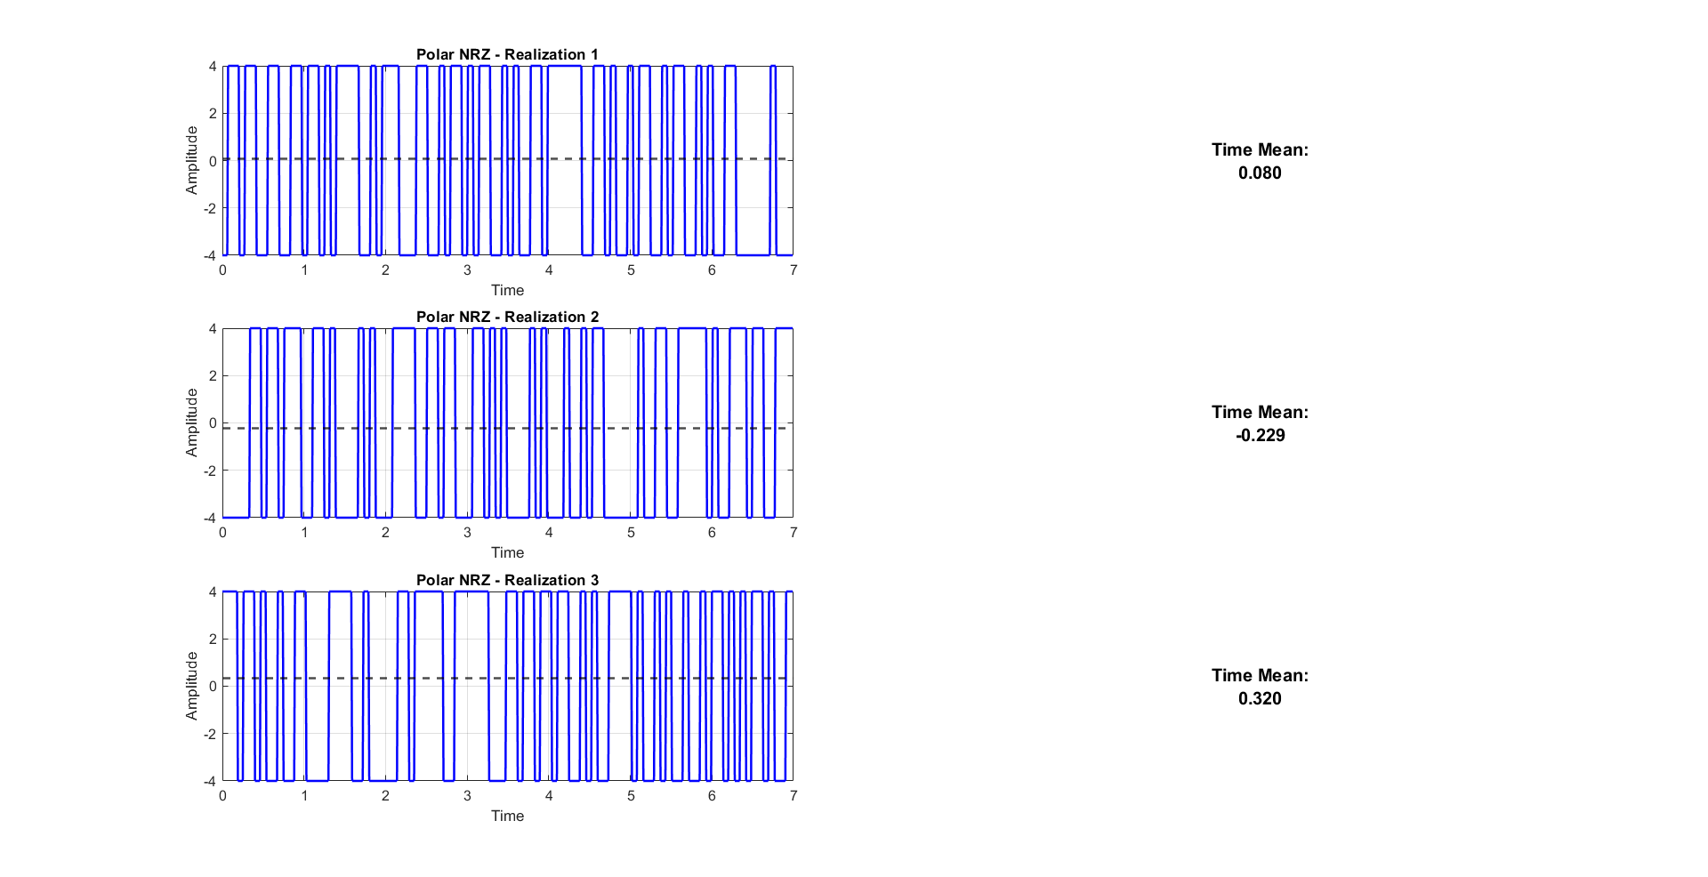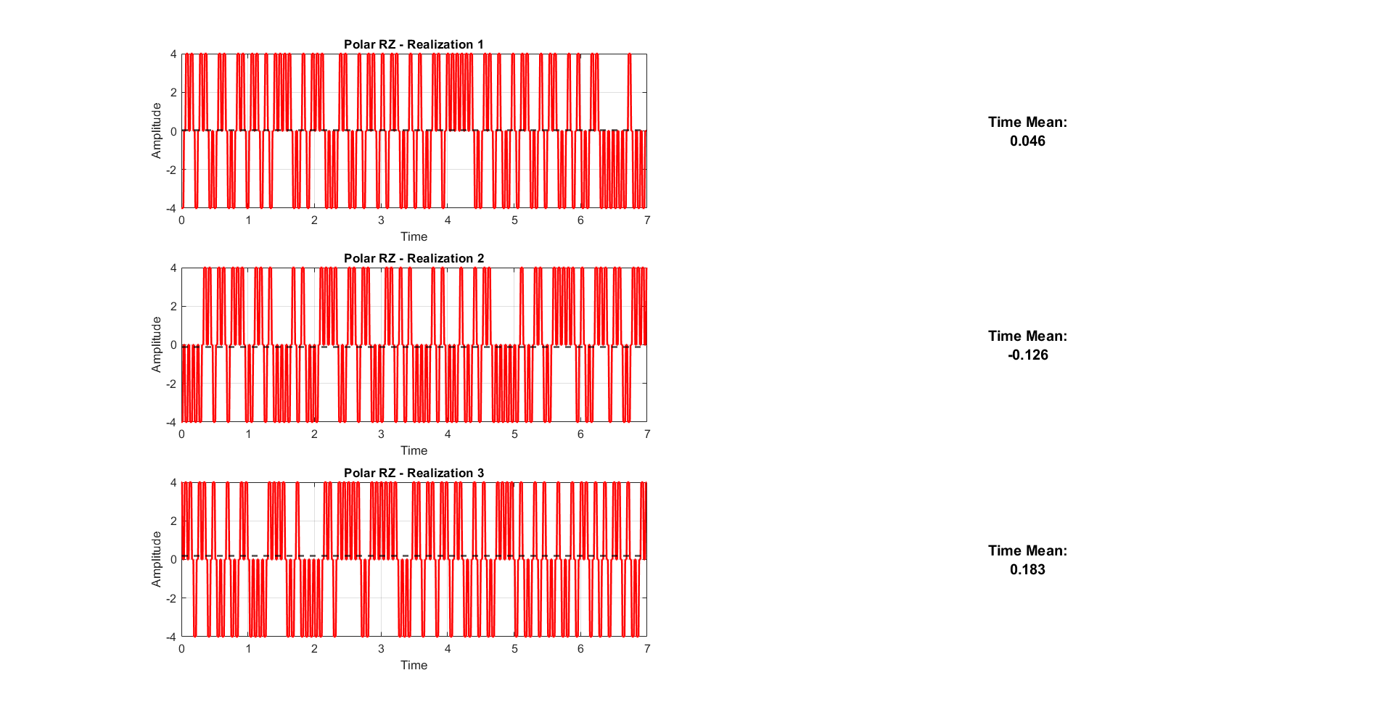 Then the average value of each realization is added to the corresponding row in the result vector (line_code_time_mean).

Figure Time Mean Ploar NRZ

Figure Time Mean Ploar RZ

* 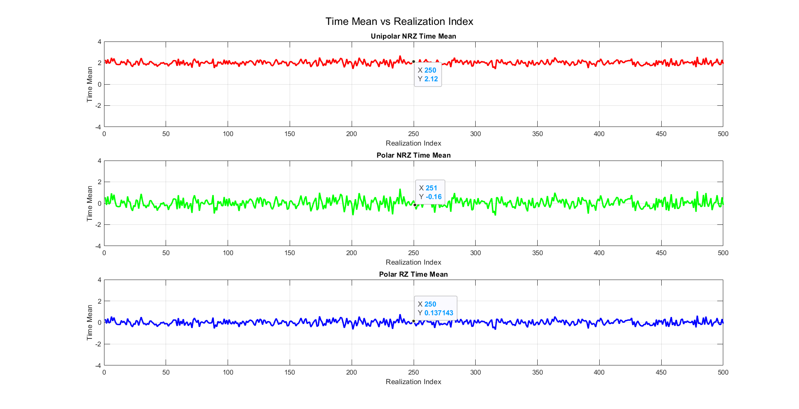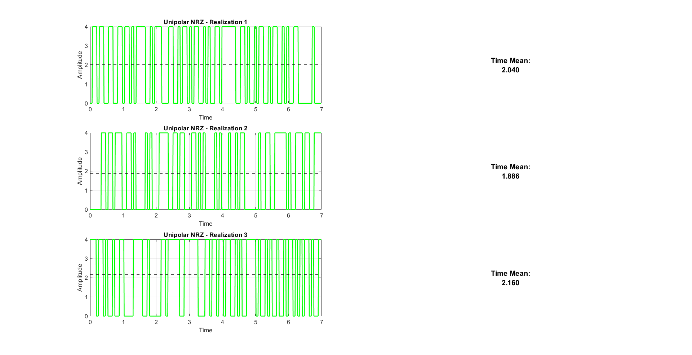 As expected, polar RZ & NRZ have almost zero mean and the uni polar has mean around 2 Bec its amplitude ranges from 0 : 4

Figure Average time mean plot for all line codes

Figure Time Mean Uni polar NRZ

### **Average Time Auto Correction**

% Initialize autocorrelation matrices (each row for a realization)

R_unipolar_nrz_t = zeros(num_realizations, length(taw2));

R_polar_nrz_t = zeros(num_realizations, length(taw2));

R_polar_rz_t = zeros(num_realizations, length(taw2));

% Compute autocorrelation for each realization separately

for r = 1:num_realizations

for i = taw2

M = i + max_lag + 1; % Shift index to fit within array bounds

% Compute sum for each lag (dot product of signal with shifted version)

if i >= 0

valid_samples = num_samples - i;

R_unipolar_nrz_t(r, M) = sum(UnipolarNRZ(r, 1:valid_samples) .* UnipolarNRZ(r, i+1:num_samples)) / valid_samples;

R_polar_nrz_t(r, M) = sum(PolarNRZ(r, 1:valid_samples) .* PolarNRZ(r, i+1:num_samples)) / valid_samples;

R_polar_rz_t(r, M) = sum(PolarRZ(r, 1:valid_samples) .* PolarRZ(r, i+1:num_samples)) / valid_samples;

else

valid_samples = num_samples + i;

R_unipolar_nrz_t(r, M) = sum(UnipolarNRZ(r, -i+1:num_samples) .* UnipolarNRZ(r, 1:valid_samples)) / valid_samples;

R_polar_nrz_t(r, M) = sum(PolarNRZ(r, -i+1:num_samples) .* PolarNRZ(r, 1:valid_samples)) / valid_samples;

R_polar_rz_t(r, M) = sum(PolarRZ(r, -i+1:num_samples) .* PolarRZ(r, 1:valid_samples)) / valid_samples;

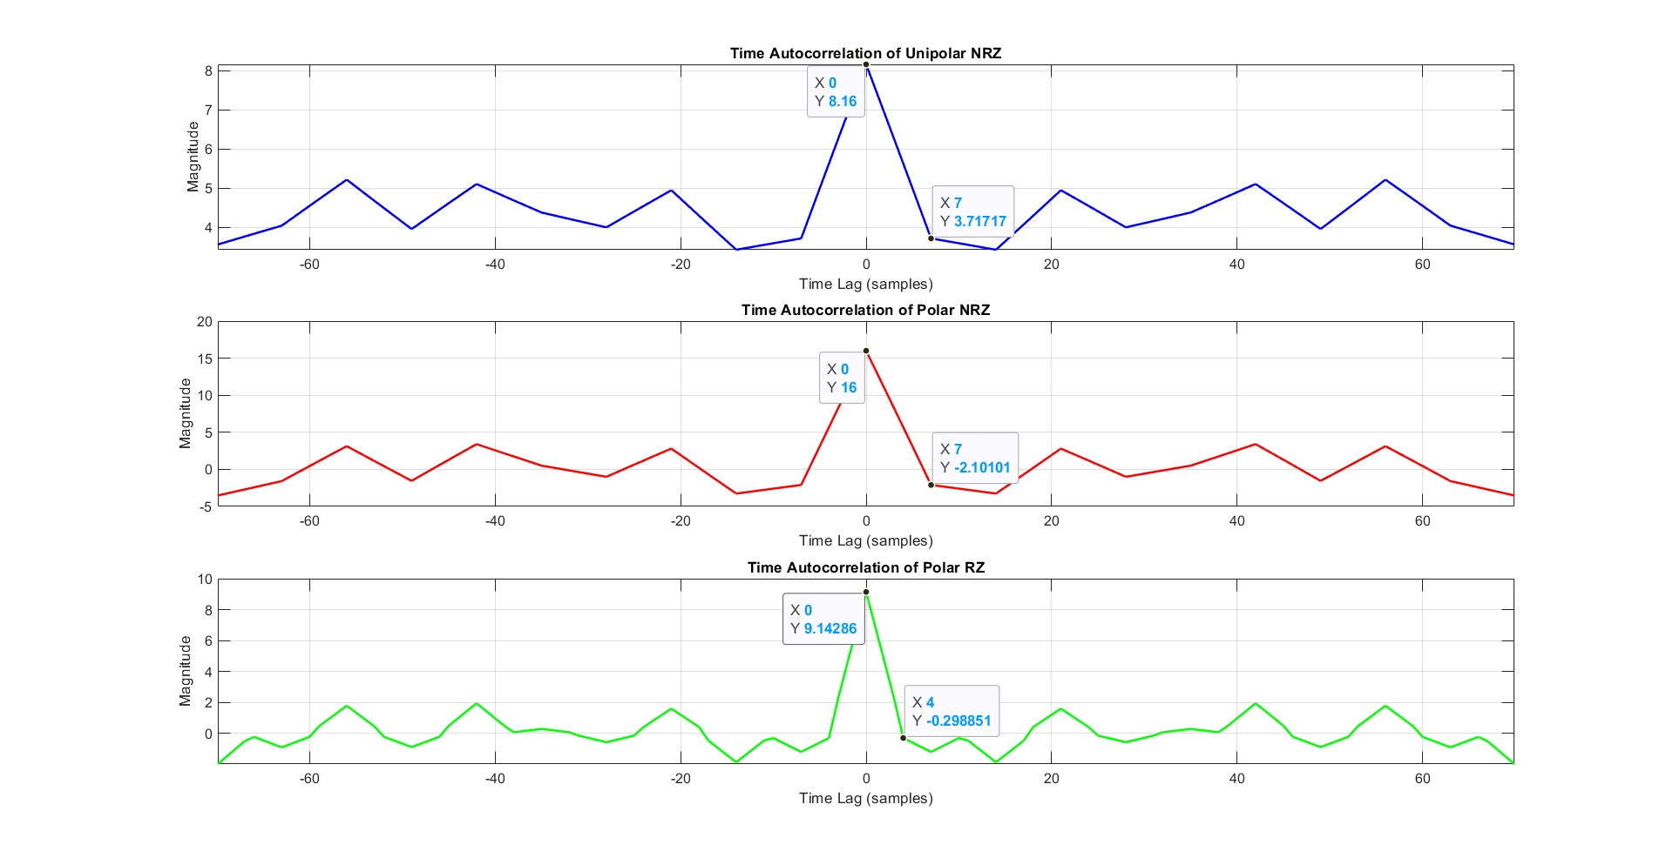 End

Figure Time Auto Correlation

* + The autocorrelation function has maximum at 𝛕 = 𝟎 and it is an even function.

## **Is The Random Process Ergodic**

Figure Comparison Between Time and Statistical Mean



* Yes, because the time mean equal to the ensemble mean and the time autocorrelation is equal to the ensemble autocorrelation.

**Then this process is ergodic**

## **the PSD & Bandwidth of the Ensemble**

function BW = find_bandwidth(PSD, freq_axis)

% Function to find the -3dB bandwidth from PSD

PSD_max = max(PSD); % Find max power

threshold = PSD_max / 2; % -3dB threshold (half power)

% Find indices where PSD is above threshold

valid_indices = find(PSD >= threshold);

% Check if we found any valid points

if isempty(valid_indices)

BW = 0; % If no valid range is found, return 0

return;

end

* We take the Fourier transform of the statistical autocorrelation then centralize the graph around zero.
* since
* Then we normalize the PSD Amplitude through dividing by Fs

**For the BW**

* the BW is the frequency of the first zero of sinc^2 function (intersection with frequency-axis)

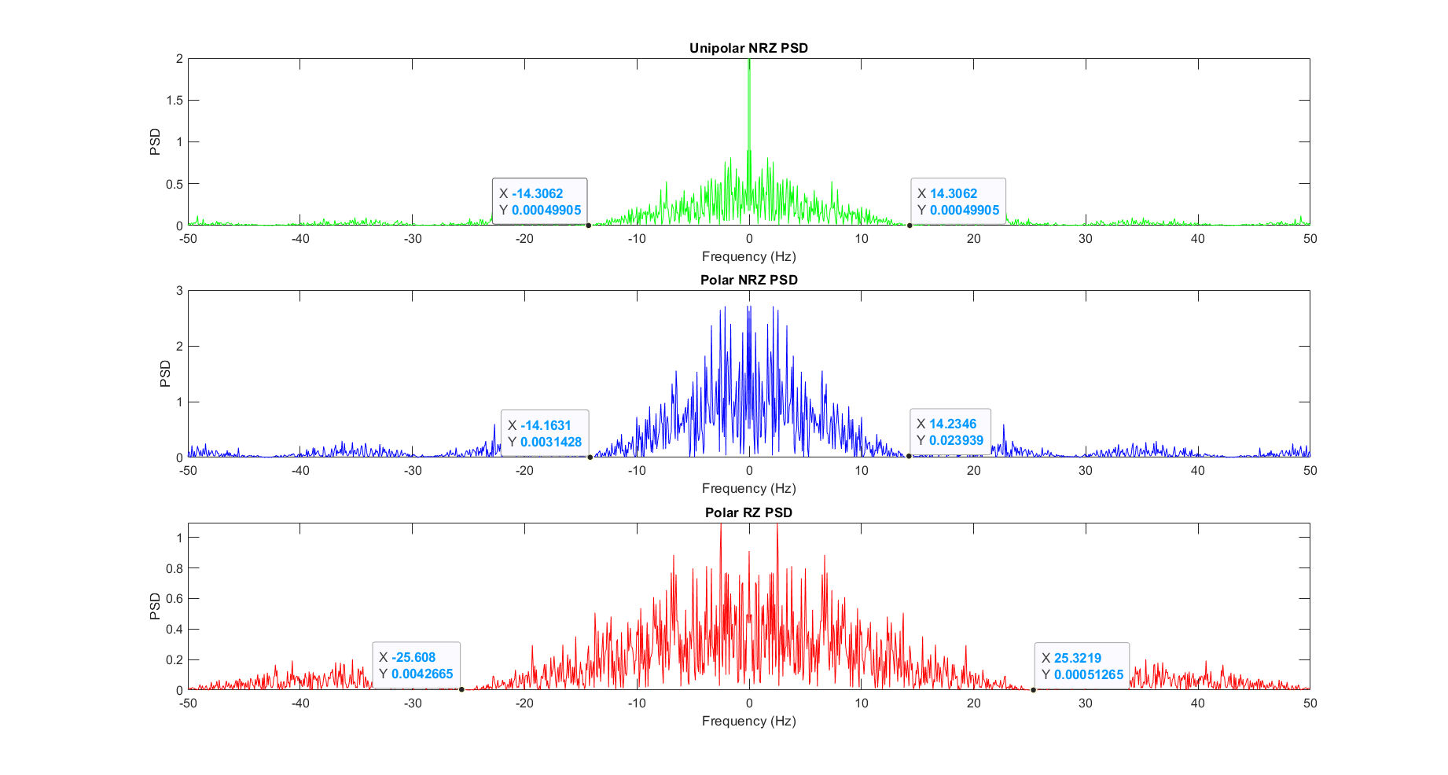

Figure PSD plot of the Ensemble

**Annotations**

* in polar RZ & NRZ : we have sinc^2 function without delta at zero frequency (NO DC)
* in uni polar NRZ : we have sinc^2 function with delta at zero frequency (there is DC)
* BW of the unipolar NRZ & polar NRZ is the bitrate which approximately equal 14.23 hz
* BW of the polar RZ is the double of bitrate which approximately equal 25.32 hz

# **Appendix**

clc;

clear;

close all;

% Parameters

A = 4; % Amplitude

N_realizations = 500; % Number of waveforms (ensemble size)

num_bits = 100+1; % Bits per waveform and one extra bit for shifting

bit_duration = 70e-3; % 70 ms per bit

dac_interval = 10e-3; % DAC updates every 10 ms

samples_per_bit = round(bit_duration / dac_interval); % 7 samples per bit

total_time = num_bits * bit_duration; % Total waveform duration

t = 0:dac_interval:(total_time - dac_interval); % Time vector

% Preallocate matrices for efficiency

Unipolar_All = zeros(N_realizations, length(t), 'int8');

PolarNRZ_All = zeros(N_realizations, length(t), 'int8');

PolarRZ_All = zeros(N_realizations, length(t), 'int8');

% Generate and store 500 realizations

for i = 1:N_realizations

Data = randi([0, 1], 1, num_bits, 'int8'); % Random bit sequence

%encode the data

[Unipolar, PolarNRZ, PolarRZ] = generate_linecodes(Data, A, samples_per_bit);

% Store in matrices

Unipolar_All(i,:) = Unipolar;

PolarNRZ_All(i,:) = PolarNRZ;

PolarRZ_All(i,:) = PolarRZ;

% Plot the first realization

if i==1

plot_linecodes(Data, Unipolar, PolarNRZ, PolarRZ, t, num_bits-1,'Realization 1');

end

end

% Plot the first 5 realizations as a sample

figure;

for i = 1:5

subplot(5,1,i);

stairs(t, Unipolar_All(i,:), 'b', 'LineWidth', 1.5);

title(['Unipolar NRZ - Realization ' num2str(i)]);

grid on;

end

xlabel('Time (s)');

% Apply random shift to all realizations

[Unipolar_Shifted, PolarNRZ_Shifted, PolarRZ_Shifted] =...

apply_random_shift_fixed_size(Unipolar_All, PolarNRZ_All, PolarRZ_All, samples_per_bit);

t_shifted = t(1:length(Unipolar_Shifted)); % Ensure the time vector matches

%plot after shift

plot_linecodes(Data, Unipolar_Shifted, PolarNRZ_Shifted, PolarRZ_Shifted,...

t_shifted, num_bits-1, 'Realization 1 shifted');

% Convert to double for accuracy

Unipolar_Shifted = double(Unipolar_Shifted);

PolarNRZ_Shifted = double(PolarNRZ_Shifted);

PolarRZ_Shifted = double(PolarRZ_Shifted);

%calculate the mean acrros time (question 1)

Unipolar_Mean = calculate_mean(Unipolar_Shifted);

PolarNRZ_Mean = calculate_mean(PolarNRZ_Shifted);

PolarRZ_Mean = calculate_mean(PolarRZ_Shifted);

%plot the mean across time

plot_mean_waveforms(t_shifted, Unipolar_Mean, PolarNRZ_Mean, PolarRZ_Mean, A);

% Compute variance for each code line

Unipolar_Var = calculate_variance(Unipolar_Shifted);

PolarNRZ_Var = calculate_variance(PolarNRZ_Shifted);

PolarRZ_Var = calculate_variance(PolarRZ_Shifted);

%plot the vatiance across time

plot_variance(t_shifted, Unipolar_Var, PolarNRZ_Var, PolarRZ_Var);

% Determine max_lag dynamically

max_lag = size(Unipolar_Shifted, 2) - 1;

%calculate the autocorrelation (question 3)

[Unipolar_AutoCorr, PolarNRZ_AutoCorr, PolarRZ_AutoCorr] = ...

compute_stat_autocorr(Unipolar_Shifted, PolarNRZ_Shifted, PolarRZ_Shifted, max_lag);

%plot the autocorrelation

plot_autocorrelation(Unipolar_AutoCorr, PolarNRZ_AutoCorr, PolarRZ_AutoCorr, max_lag)

% Compute time autocorrelation

[R_unipolar_nrz_t, R_polar_nrz_t, R_polar_rz_t, taw] =...

compute_time_autocorr(Unipolar_Shifted, PolarNRZ_Shifted, PolarRZ_Shifted);

% Plot the time autocorrelation

plot_time_autocorrelation(R_unipolar_nrz_t, R_polar_nrz_t, R_polar_rz_t, taw, max_lag);

% Compute time mean for each line code

Unipolar_TimeMean = compute_time_mean(Unipolar_Shifted);

PolarNRZ_TimeMean = compute_time_mean(PolarNRZ_Shifted);

PolarRZ_TimeMean = compute_time_mean(PolarRZ_Shifted);

% Plot the time mean

plot_realizations_with_mean(t_shifted, Unipolar_TimeMean, Unipolar_Shifted, 'Unipolar NRZ', 'g');

plot_realizations_with_mean(t_shifted, PolarNRZ_TimeMean, PolarNRZ_Shifted, 'Polar NRZ', 'b');

plot_realizations_with_mean(t_shifted, PolarRZ_TimeMean, PolarRZ_Shifted, 'Polar RZ', 'r');

%Plot time mean vs realization

plot_time_mean_vs_realization(Unipolar_TimeMean, PolarNRZ_TimeMean, PolarRZ_TimeMean, A);

fs = 100; % Sampling frequency

[BW_unipolar, BW_polarNRZ, BW_polarRZ] = ...

estimate_all_bandwidths(R_unipolar_nrz_t, R_polar_nrz_t, R_polar_rz_t, fs);

%-----------------------Functions----------------------------

function [Unipolar, PolarNRZ, PolarRZ] = generate_linecodes(Data, A, samples_per_bit)

% Ensure input Data is of type int8

Data = int8(Data);

% Convert samples_per_bit to double for safe calculations

samples_per_bitd = double(samples_per_bit);

% Unipolar NRZ: 0 → 0V, 1 → A

Unipolar = int8(Data * A);

Unipolar = repelem(Unipolar, samples_per_bit); % Repeat each bit for duration

% Polar NRZ: 0 → -A, 1 → +A

PolarNRZ = int8((2 * Data - 1) * A);

PolarNRZ = repelem(PolarNRZ, samples_per_bit);

% Polar Return-to-Zero (RZ): Same as Polar NRZ but second half set to 0

PolarRZ = PolarNRZ;

% Apply RZ rule: second half of each bit period should be zero

i = length(Data); % Start from the last bit

while i > 0

end_idx = i * samples_per_bitd; % Last sample of the bit

start_idx = end_idx - floor(samples_per_bitd / 2) + 1; % Start of the second half

PolarRZ(start_idx:end_idx) = 0; % Set the second half of the bit period to zero

i = i - 1; % Move to the previous bit

end

end

function plot_linecodes(Data, Unipolar, PolarNRZ, PolarRZ, t, num_bits_to_show, plot_title)

% Ensure num_bits_to_show does not exceed the actual number of bits

num_samples_per_bit = ceil(length(t) / length(Data));

num_samples_to_show = num_bits_to_show * num_samples_per_bit;

% Trim the signals to display only the required number of bits

t_show = t(1:num_samples_to_show);

Unipolar_show = Unipolar(1, 1:num_samples_to_show); % Select row 1 explicitly

PolarNRZ_show = PolarNRZ(1, 1:num_samples_to_show);

PolarRZ_show = PolarRZ(1, 1:num_samples_to_show);

% Convert Data into a sample-wise representation for accurate plotting

Data_show = repelem(Data(1:num_bits_to_show), num_samples_per_bit);

Data_t = t(1:length(Data_show)); % Adjust time axis

% Plot the signals

figure;

sgtitle(plot_title); % Set a title for the entire figure

subplot(4,1,1);

stairs(Data_t, Data_show, 'k', 'LineWidth', 2);

title('Orignal Data');

ylim([-0.5, 1.5]); % Keep the binary level range

yticks([0 1]);

yticklabels({'0', '1'});

grid on;

subplot(4,1,2);

stairs(t_show, Unipolar_show, 'b', 'LineWidth', 2);

title('Unipolar NRZ');

grid on;

subplot(4,1,3);

stairs(t_show, PolarNRZ_show, 'r', 'LineWidth', 2);

title('Polar NRZ');

grid on;

subplot(4,1,4);

stairs(t_show, PolarRZ_show, 'm', 'LineWidth', 2);

title('Polar RZ');

grid on;

xlabel('Time (s)');

end

function [Unipolar_Shifted, PolarNRZ_Shifted, PolarRZ_Shifted] =...

apply_random_shift_fixed_size(Unipolar_All, PolarNRZ_All, PolarRZ_All, samples_per_bit)

% Define parameters

N_realizations = size(Unipolar_All, 1); % 500 realizations

extended_samples = size(Unipolar_All, 2); % 707 samples

total_samples = 700; % Fixed output size

% Initialize shifted matrices

Unipolar_Shifted = zeros(N_realizations, total_samples, 'int8');

PolarNRZ_Shifted = zeros(N_realizations, total_samples, 'int8');

PolarRZ_Shifted = zeros(N_realizations, total_samples, 'int8');

% Apply random shift to each realization

for i = 1:N_realizations

% Generate random shift in range [0, samples_per_bit-1] samples

random_shift_bits = randi([0, samples_per_bit-1]);

% Extract shifted region

Unipolar_Shifted(i, :) = Unipolar_All(i, random_shift_bits+1 : random_shift_bits+total_samples);

PolarNRZ_Shifted(i, :) = PolarNRZ_All(i, random_shift_bits+1 : random_shift_bits+total_samples);

PolarRZ_Shifted(i, :) = PolarRZ_All(i, random_shift_bits+1 : random_shift_bits+total_samples);

end

end

function mean_waveform = calculate_mean(waveform_matrix)

% Calculates the mean across all realizations without using the mean function

% waveform_matrix: Matrix where each row is a realization

[num_realizations, num_samples] = size(waveform_matrix); % Get matrix dimensions

mean_waveform = sum(waveform_matrix, 1) / num_realizations; % Sum and divide by count

end

function plot_mean_waveforms(t, Unipolar_Mean, PolarNRZ_Mean, PolarRZ_Mean, A)

% Function to plot the mean waveforms of different line codes across time

% Inputs:

% t - Time vector

% Unipolar_Mean - Mean waveform of Unipolar NRZ

% PolarNRZ_Mean - Mean waveform of Polar NRZ

% PolarRZ_Mean - Mean waveform of Polar RZ

% A - Amplitude limit

figure;

subplot(3,1,1);

plot(t, Unipolar_Mean, 'r', 'LineWidth', 2);

xlabel('Time (s)');

ylabel('Amplitude');

title('Mean of Unipolar NRZ');

grid on;

ylim([-A, A]); % Set y-axis limits

subplot(3,1,2);

plot(t, PolarNRZ_Mean, 'g', 'LineWidth', 2);

xlabel('Time (s)');

ylabel('Amplitude');

title('Mean of Polar NRZ');

grid on;

ylim([-A, A]);

subplot(3,1,3);

plot(t, PolarRZ_Mean, 'b', 'LineWidth', 2);

xlabel('Time (s)');

ylabel('Amplitude');

title('Mean of Polar RZ');

grid on;

ylim([-A, A]);

% Add a super title for the whole figure

sgtitle('Mean of Different Line Codes');

end

function variance_waveform = calculate_variance(waveform_matrix)

% Calculates the variance across all realizations (column-wise)

% waveform_matrix: Matrix where each row is a realization (num_realizations x num_samples)

% Returns: variance_waveform (1 x num_samples), representing the variance of each sample point

% Compute the mean using the previously implemented function

mean_waveform = calculate_mean(waveform_matrix);

[num_realizations, num_samples] = size(waveform_matrix); % Get dimensions

% Ensure mean_waveform is the same size for element-wise subtraction

mean_waveform = repmat(mean_waveform, num_realizations, 1);

% Compute variance manually using the variance formula

variance_waveform = sum((waveform_matrix - mean_waveform).^2, 1) / num_realizations; % Population variance

end

function plot_variance(t, Unipolar_Var, PolarNRZ_Var, PolarRZ_Var)

% Plots the variance of different line codes over time

% t: Time vector

% Unipolar_Var, PolarNRZ_Var, PolarRZ_Var: Variance waveforms

figure;

subplot(3,1,1);

plot(t, Unipolar_Var, 'r', 'LineWidth', 2);

xlabel('Time (s)');

ylabel('Variance');

title('Variance of Unipolar NRZ');

grid on;

subplot(3,1,2);

plot(t, PolarNRZ_Var, 'g', 'LineWidth', 2);

xlabel('Time (s)');

ylabel('Variance');

title('Variance of Polar NRZ');

grid on;

subplot(3,1,3);

plot(t, PolarRZ_Var, 'b', 'LineWidth', 2);

xlabel('Time (s)');

ylabel('Variance');

title('Variance of Polar RZ');

grid on;

% Add a super title for clarity

sgtitle('Variance of Different Line Codes');

end

function [Unipolar_AutoCorr, PolarNRZ_AutoCorr, PolarRZ_AutoCorr] =...

compute_stat_autocorr(Unipolar_Shifted, PolarNRZ_Shifted, PolarRZ_Shifted, max_lag)

% Compute Statistical Autocorrelation for given signals using calculate_mean

% Inputs:

% Unipolar_Shifted - Shifted signal matrix for Unipolar NRZ

% PolarNRZ_Shifted - Shifted signal matrix for Polar NRZ

% PolarRZ_Shifted - Shifted signal matrix for Polar RZ

% Outputs:

% Unipolar_AutoCorr - Computed autocorrelation for Unipolar NRZ

% PolarNRZ_AutoCorr - Computed autocorrelation for Polar NRZ

% PolarRZ_AutoCorr - Computed autocorrelation for Polar RZ

% Set x-axis limits dynamically

x_limit = max_lag / 10;

% Initialize autocorrelation arrays

Unipolar_AutoCorr = zeros(1, max_lag + 1);

PolarNRZ_AutoCorr = zeros(1, max_lag + 1);

PolarRZ_AutoCorr = zeros(1, max_lag + 1);

% Compute mean autocorrelation using calculate_mean function

for i = 0:max_lag

Unipolar_AutoCorr(i+1) = calculate_mean(Unipolar_Shifted(:, 1) .* Unipolar_Shifted(:, i+1));

PolarNRZ_AutoCorr(i+1) = calculate_mean(PolarNRZ_Shifted(:, 1) .* PolarNRZ_Shifted(:, i+1));

PolarRZ_AutoCorr(i+1) = calculate_mean(PolarRZ_Shifted(:, 1) .* PolarRZ_Shifted(:, i+1));

end

% Time axis for plotting

t = -max_lag:max_lag;

% Compute symmetric autocorrelation values

Unipolar_AutoCorr = [fliplr(Unipolar_AutoCorr), Unipolar_AutoCorr(2:end)];

PolarNRZ_AutoCorr = [fliplr(PolarNRZ_AutoCorr), PolarNRZ_AutoCorr(2:end)];

PolarRZ_AutoCorr = [fliplr(PolarRZ_AutoCorr), PolarRZ_AutoCorr(2:end)];

end

function plot_autocorrelation(Unipolar_AutoCorr, PolarNRZ_AutoCorr, PolarRZ_AutoCorr, max_lag)

% Plots the statistical autocorrelation of Unipolar NRZ, Polar NRZ, and Polar RZ

% Inputs:

% Unipolar_AutoCorr - Autocorrelation for Unipolar NRZ

% PolarNRZ_AutoCorr - Autocorrelation for Polar NRZ

% PolarRZ_AutoCorr - Autocorrelation for Polar RZ

% max_lag - Maximum lag value used for the time axis

% Time axis

t = -max_lag:max_lag;

% Compute x-axis limit

x_limit = max_lag / 10;

% Plot results

figure("name", "Statistical Autocorrelation");

subplot(3,1,1);

plot(t, Unipolar_AutoCorr, 'g');

xlim([-x_limit x_limit]);

xlabel("Time axis");

ylabel("Autocorr axis");

title("Unipolar NRZ Statistical Autocorrelation");

subplot(3,1,2);

plot(t, PolarNRZ_AutoCorr, 'b');

xlim([-x_limit x_limit]);

xlabel("Time axis");

ylabel("Autocorr axis");

title("Polar NRZ Statistical Autocorrelation");

subplot(3,1,3);

plot(t, PolarRZ_AutoCorr, 'r');

xlim([-x_limit x_limit]);

xlabel("Time axis");

ylabel("Autocorr axis");

title("Polar RZ Statistical Autocorrelation");

end

function TimeMean = compute_time_mean(waveform_matrix)

% Computes the time mean for each realization of a given waveform

% Inputs:

% waveform_matrix - Matrix where each row represents a realization

% Output:

% TimeMean - Column vector containing the time mean for each realization

% Compute time mean for each realization (mean along rows)

TimeMean = sum(waveform_matrix, 2) / size(waveform_matrix, 2);

end

function plot_realizations_with_mean(t_shifted, Signals_TimeMean, signals_waveform, signal_name, color)

% Plots the first 3 realizations of a signal in a 3x2 grid and displays their time means as text.

%

% Inputs:

% t_shifted - Time vector

% Signals_TimeMean - Vector of time means (one per realization)

% signals_waveform - Matrix where each row is a realization

% signal_name - Name of the signal (string) for labeling

% color - Plot color (e.g., 'g' for green)

figure('Name', [signal_name, ' - Realizations and Time Mean']);

for i = 1:3

% First Column: Plot the waveform realization

subplot(3,2,(i-1)*2+1);

plot(t_shifted, signals_waveform(i,:), color, 'LineWidth', 1.5); % Plot waveform

hold on;

yline(Signals_TimeMean(i), '--k', 'LineWidth', 1.5); % Add time mean line

hold off;

xlabel('Time');

ylabel('Amplitude');

title([signal_name, ' - Realization ', num2str(i)]);

grid on;

% Second Column: Display time mean as a text box

subplot(3,2,(i-1)*2+2);

axis off; % Hide axes for a clean text display

text(0.5, 0.5, sprintf('Time Mean:\n%.3f', Signals_TimeMean(i)), ...

'FontSize', 12, 'FontWeight', 'bold', 'HorizontalAlignment', 'center', 'BackgroundColor', 'w');

end

end

function plot_time_mean_vs_realization(unipolar_mean, polarNRZ_mean, polarRZ_mean, A)

% Function to plot the time mean vs realization index for different signals separately

%

% Inputs:

% - unipolar_mean: Time mean of Unipolar NRZ (1xN vector)

% - polarNRZ_mean: Time mean of Polar NRZ (1xN vector)

% - polarRZ_mean: Time mean of Polar RZ (1xN vector)

% - A: Amplitude limit for y-axis

% Define the x-axis (Index based on row size)

num_realizations = length(unipolar_mean);

realization_indices = 1:num_realizations;

% Create a figure for subplots

figure;

% Subplot 1: Unipolar NRZ

subplot(3,1,1);

plot(realization_indices, unipolar_mean, 'r', 'LineWidth', 2);

grid on;

xlabel('Realization Index');

ylabel('Time Mean');

title('Unipolar NRZ Time Mean');

ylim([-A, A]); % Set y-axis limits

% Subplot 2: Polar NRZ

subplot(3,1,2);

plot(realization_indices, polarNRZ_mean, 'g', 'LineWidth', 2);

grid on;

xlabel('Realization Index');

ylabel('Time Mean');

title('Polar NRZ Time Mean');

ylim([-A, A]);

% Subplot 3: Polar RZ

subplot(3,1,3);

plot(realization_indices, polarRZ_mean, 'b', 'LineWidth', 2);

grid on;

xlabel('Realization Index');

ylabel('Time Mean');

title('Polar RZ Time Mean');

ylim([-A, A]);

% Add a super title for the whole figure

sgtitle('Time Mean vs Realization Index');

end

function [R_unipolar_nrz_t, R_polar_nrz_t, R_polar_rz_t, taw2] = ...

compute_time_autocorr(UnipolarNRZ, PolarNRZ, PolarRZ)

% Computes time autocorrelation for each realization separately.

%

% Inputs:

% UnipolarNRZ - Matrix containing all realizations for Unipolar NRZ

% PolarNRZ - Matrix containing all realizations for Polar NRZ

% PolarRZ - Matrix containing all realizations for Polar RZ

%

% Outputs:

% R_unipolar_nrz_t - Time autocorrelation for Unipolar NRZ (each row computed separately)

% R_polar_nrz_t - Time autocorrelation for Polar NRZ (each row computed separately)

% R_polar_rz_t - Time autocorrelation for Polar RZ (each row computed separately)

% Get number of realizations and samples

[num_realizations, num_samples] = size(UnipolarNRZ);

% Define range of time lags

max_lag = num_samples - 1; % Maximum lag value

taw2 = -max_lag:max_lag; % Lag vector

% Initialize autocorrelation matrices (each row for a realization)

R_unipolar_nrz_t = zeros(num_realizations, length(taw2));

R_polar_nrz_t = zeros(num_realizations, length(taw2));

R_polar_rz_t = zeros(num_realizations, length(taw2));

% Compute autocorrelation for each realization separately

for r = 1:num_realizations

for i = taw2

M = i + max_lag + 1; % Shift index to fit within array bounds

% Compute sum for each lag (dot product of signal with shifted version)

if i >= 0

valid_samples = num_samples - i;

R_unipolar_nrz_t(r, M) = sum(UnipolarNRZ(r, 1:valid_samples) .* UnipolarNRZ(r, i+1:num_samples)) / valid_samples;

R_polar_nrz_t(r, M) = sum(PolarNRZ(r, 1:valid_samples) .* PolarNRZ(r, i+1:num_samples)) / valid_samples;

R_polar_rz_t(r, M) = sum(PolarRZ(r, 1:valid_samples) .* PolarRZ(r, i+1:num_samples)) / valid_samples;

else

valid_samples = num_samples + i;

R_unipolar_nrz_t(r, M) = sum(UnipolarNRZ(r, -i+1:num_samples) .* UnipolarNRZ(r, 1:valid_samples)) / valid_samples;

R_polar_nrz_t(r, M) = sum(PolarNRZ(r, -i+1:num_samples) .* PolarNRZ(r, 1:valid_samples)) / valid_samples;

R_polar_rz_t(r, M) = sum(PolarRZ(r, -i+1:num_samples) .* PolarRZ(r, 1:valid_samples)) / valid_samples;

end

end

end

end

function plot_time_autocorrelation(R_unipolar, R_polarNRZ, R_polarRZ, taw, max_lag)

% Plots the time autocorrelation of the first realization for each waveform type.

%

% Inputs:

% R_unipolar - Matrix containing time autocorrelation for Unipolar NRZ (each row is a realization)

% R_polarNRZ - Matrix containing time autocorrelation for Polar NRZ (each row is a realization)

% R_polarRZ - Matrix containing time autocorrelation for Polar RZ (each row is a realization)

% taw - Vector of lag values

% max_lag - Maximum lag value to set axis limits dynamically

% Set dynamic x-axis limits based on max_lag

x_limit = max_lag / 10;

figure('Name', 'Time Autocorrelation');

% Plot Unipolar NRZ

subplot(3,1,1);

plot(taw, R_unipolar(1, :), 'b', 'LineWidth', 1.5);

grid on;

xlim([-x_limit x_limit]); % Adjust only the x-axis dynamically

xlabel('Time Lag (samples)');

ylabel('Magnitude');

title('Time Autocorrelation of Unipolar NRZ');

% Plot Polar NRZ

subplot(3,1,2);

plot(taw, R_polarNRZ(1, :), 'r', 'LineWidth', 1.5);

grid on;

xlim([-x_limit x_limit]); % Adjust only the x-axis dynamically

xlabel('Time Lag (samples)');

ylabel('Magnitude');

title('Time Autocorrelation of Polar NRZ');

% Plot Polar RZ

subplot(3,1,3);

plot(taw, R_polarRZ(1, :), 'g', 'LineWidth', 1.5);

grid on;

xlim([-x_limit x_limit]); % Adjust only the x-axis dynamically

xlabel('Time Lag (samples)');

ylabel('Magnitude');

title('Time Autocorrelation of Polar RZ');

end

function [BW_unipolar, BW_polarNRZ, BW_polarRZ] = ...

estimate_all_bandwidths(R_unipolar_nrz, R_polar_nrz, R_polar_rz, fs)

% Function to estimate the bandwidth for Unipolar NRZ, Polar NRZ, and Polar RZ

% using FFT and power spectral density (PSD) method.

% Extract the first realization

R_unipolar_nrz = R_unipolar_nrz(:,1);

R_polar_nrz = R_polar_nrz(:,1);

R_polar_rz = R_polar_rz(:,1);

% Number of samples (adjust dynamically)

n = length(R_unipolar_nrz);

% Compute FFT coefficients

unipolar_nrz_coe = fft(R_unipolar_nrz) / n;

polar_nrz_coe = fft(R_polar_nrz) / n;

polar_rz_coe = fft(R_polar_rz) / n;

% Compute magnitude of FFT (PSD estimation)

amplitude_unipolar_nrz = abs(unipolar_nrz_coe);

amplitude_polar_nrz = abs(polar_nrz_coe);

amplitude_polar_rz = abs(polar_rz_coe);

% Frequency axis mapping (centered around 0)

freq_axis = (-n/2:n/2-1) * (fs / n); % Corrected frequency scaling

% Shift FFT for centered display

amp_unipolar_nrz = fftshift(amplitude_unipolar_nrz);

amp_polar_nrz = fftshift(amplitude_polar_nrz);

amp_polar_rz = fftshift(amplitude_polar_rz);

% Estimate bandwidths using -3dB method

BW_unipolar = find_bandwidth(amp_unipolar_nrz, freq_axis);

BW_polarNRZ = find_bandwidth(amp_polar_nrz, freq_axis);

BW_polarRZ = find_bandwidth(amp_polar_rz, freq_axis);

%{

% Display Bandwidth Values

disp(['BW Unipolar NRZ: ', num2str(BW_unipolar), ' Hz']);

disp(['BW Polar NRZ: ', num2str(BW_polarNRZ), ' Hz']);

disp(['BW Polar RZ: ', num2str(BW_polarRZ), ' Hz']);

%}

% Plot PSDs

figure('Name', 'Power Spectral Density');

subplot(3,1,1);

plot(freq_axis, amp_unipolar_nrz, 'g');

ylim([0 max(amp_unipolar_nrz)*1.1]); xlim([-fs/2 fs/2]);

grid on;

xlabel('Frequency (Hz)');

ylabel('Magnitude');

title('PSD of Unipolar NRZ');

subplot(3,1,2);

plot(freq_axis, amp_polar_nrz, 'b');

ylim([0 max(amp_polar_nrz)*1.1]); xlim([-fs/2 fs/2]);

grid on;

xlabel('Frequency (Hz)');

ylabel('Magnitude');

title('PSD of Polar NRZ');

subplot(3,1,3);

plot(freq_axis, amp_polar_rz, 'r');

ylim([0 max(amp_polar_rz)*1.1]); xlim([-fs/2 fs/2]);

grid on;

xlabel('Frequency (Hz)');

ylabel('Magnitude');

title('PSD of Polar RZ');

end

function BW = find_bandwidth(PSD, freq_axis)

% Function to find the -3dB bandwidth from PSD

PSD_max = max(PSD); % Find max power

threshold = PSD_max / 2; % -3dB threshold (half power)

% Find indices where PSD is above threshold

valid_indices = find(PSD >= threshold);

% Check if we found any valid points

if isempty(valid_indices)

BW = 0; % If no valid range is found, return 0

return;

end

% Ensure indices are within valid bounds

min_index = max(1, min(valid_indices)); % Ensure it's at least 1

max_index = min(length(freq_axis), max(valid_indices)); % Ensure it's within bounds

% Compute bandwidth as the difference between first and last crossing points

BW = abs(freq_axis(max_index) - freq_axis(min_index));

end